 IDE is an easy-to-use interface that records user interactions on the browser and exports them as a reusable script.

can be used by engineers with no programming knowledge whatsoever.

Record and play Available for Chrome, Firefox, Chromium etc.,

Working Principle of Selenium IDE

IDE works in three stages: recording, playing back and saving.

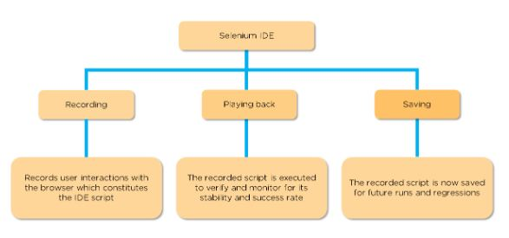

Fig: Selenium IDE working principle

In the next section, we’ll learn about the three stages in detail, but before we begin, let’s acquaint ourselves with the installation of IDE.

Recording

IDE allows the user to record all of the actions performed in the browser. These recorded actions as a whole are the test script.

Playing Back

The recorded script can now be executed to ensure that the browser is working accordingly. Now, the user can monitor the stability and success rate.

Saving

The recorded script is saved with a “.side” extension for future runs and regressions.

**Limitations of Selenium IDE**

* Not suitable for testing extensive data
* Connections with the database can not be tested
* Cannot handle the dynamic part of web-based applications
* Does not support capturing of screenshots on test failures
* No feature available for generating result reports

https://www.browserstack.com/guide/what-is-selenium-ide#:~:text=Selenium%20IDE%20(Integrated%20Development%20Environment,cases%20for%20their%20web%20applications.

https://www.youtube.com/watch?v=GYXJXAWBjc4